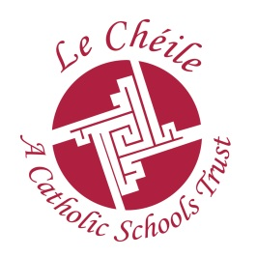
Founded 1953
Templeogue Road, Terenure, Dublin 6w
Telephone 4903241 Fax 4922511
Email: admin@olschool.ie

Our Lady’s School

March 2019

Dear Parents/Guardians,

I want to take this opportunity to reiterate a few details pertaining to your daughters’ work experience placement 2019/2020.

Your daughter has been advised to secure three different work experience placements and one Community Service placement. The dates of these are
- Placement 1 21st – 25th October 2019
- Placement 2 10th -14th February 2020
- Placement 3 23rd – 27th March 2020
- Placement 4 30th March -3rd April 2020

Your daughter will be covered by school insurance while on placement. It will be renewed on an annual basis in October. We recommend, due to the restrictions in school insurance, that your daughter does not work an evening job or find a work placement working with large animals.
Absences- Students must inform their employer first and subsequently inform the school. This must be done prior to start of business on the day of absence.

Garda Vetting- Please find attached the new forms for Garda Vetting. This is required for student between 16-18 years who wish to work with children or vulnerable adults.

If you own a business or work in a company that could accept one of our students on placement, please email me on workexperience@olschool.ie. We are always looking to make new connections with employers and would really appreciate your continued support.

Please take this opportunity to discuss preferential work placements with your daughter. Where possible, students are encouraged to find placements in work related to the career in which they have a special interest. It is the responsibility of each student to make his/her own application and to find their own work experience placement as this is an essential element of preparation for the world of work. Signed paperwork, email confirmations and letters are due to be returned to me in August when your daughter returns for the upcoming school year.
Thank you again for your participation in our programme. We wish the girls the very best of luck in their upcoming exams and hope they enjoy a relaxing summer.

Yours Faithfully,
______________________________
Caitríona Coyne
Work Experience Co-ordinator
workexperience@olschool.ie

